J.P.BADRI(192524301)
Set 1: Monthly Sales Data
Dataset: Monthly Sales
- Create a line chart to visualize the monthly sales. Label the axes and title the chart appropriately.
- Generate a bar chart to display the top-selling products for the year. Label the chart elements.
- Develop a scatter plot to explore the relationship between advertising budget and monthly sales.
Explain the insights drawn from the scatter plot.
- Build an interactive dashboard combining the line chart and bar chart to allow users to explore sales data interactively.

SOLUTION :

CODE :

!pip install wordcloud matplotlib seaborn plotly pandas -q

import pandas as pd import numpy as np import matplotlib.pyplot as plt import seaborn as sns import plotly.express as px import plotly.graph_objects as gg

months = ['Jan', 'Feb', 'Mar', 'Apr', 'May', 'Jun', 'Jul', 'Aug', 'Sep', 'Oct', 'Nov', 'Dec'] sales_data = pd.DataFrame({
'Month': months,
'Sales': [15000, 18000, 22000, 20000, 23000, 25000, 27000, 26000, 29000, 31000, 35000, 40000],
'Ad_Budget': [1200, 1500, 1800, 1600, 1900, 2100, 2300, 2200, 2500, 2700, 3100, 3600] })

products_data = pd.DataFrame({
'Product': ['Product A', 'Product B', 'Product C', 'Product D', 'Product E'],
'Sales_Units': [450, 380, 310, 290, 180]
})

plt.figure(figsize=(8, 4)) plt.plot(sales_data['Month'], sales_data['Sales'], marker='o', color='b', linewidth=2) plt.title('Monthly Sales Performance', fontsize=14) plt.xlabel('Month', fontsize=12) plt.ylabel('Sales ($)', fontsize=12) plt.grid(True, linestyle='--', alpha=0.6) plt.tight_layout() plt.show()

plt.figure(figsize=(8, 4))
plt.bar(products_data['Product'], products_data['Sales_Units'], color='skyblue', edgecolor='black') plt.title('Top-Selling Products for the Year', fontsize=14) plt.xlabel('Product', fontsize=12) plt.ylabel('Units Sold', fontsize=12) for i, val in enumerate(products_data['Sales_Units']):
plt.text(i, val + 5, str(val), ha='center', fontweight='bold') plt.tight_layout() plt.show()

plt.figure(figsize=(8, 4)) sns.regplot(data=sales_data, x='Ad_Budget', y='Sales', color='darkgreen', marker='s') plt.title('Advertising Budget vs. Monthly Sales', fontsize=14) plt.xlabel('Advertising Budget ($)', fontsize=12) plt.ylabel('Monthly Sales ($)', fontsize=12) plt.grid(True, linestyle='--', alpha=0.6) plt.tight_layout() plt.show()

print("--- Insights from Scatter Plot ---")
print("There is a strong positive linear correlation between advertising budget and monthly sales.")
print("As the advertising expenditure increases, monthly sales steadily rise, suggesting advertising spend directly drives revenue growth.\n")

from plotly.subplots import make_subplots

fig = make_subplots( rows=1, cols=2, subplot_titles=("Monthly Sales Trend", "Top-Selling Products")
)

fig.add_trace(
gg.Scatter(x=sales_data['Month'], y=sales_data['Sales'], mode='lines+markers', name='Sales ($)'), row=1, col=1
)

fig.add_trace(
gg.Bar(x=products_data['Product'], y=products_data['Sales_Units'], name='Units Sold', marker_color='teal'), row=1, col=2
)

fig.update_layout(title_text="Set 1: Interactive Sales Exploration Dashboard", showlegend=False, height=450) fig.show()

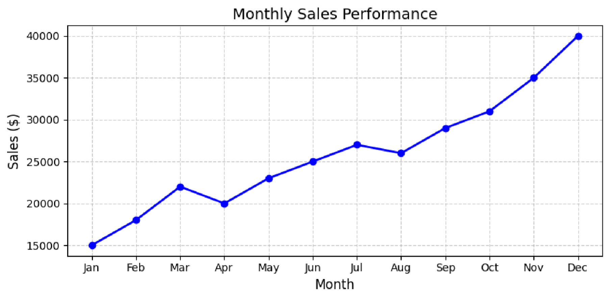
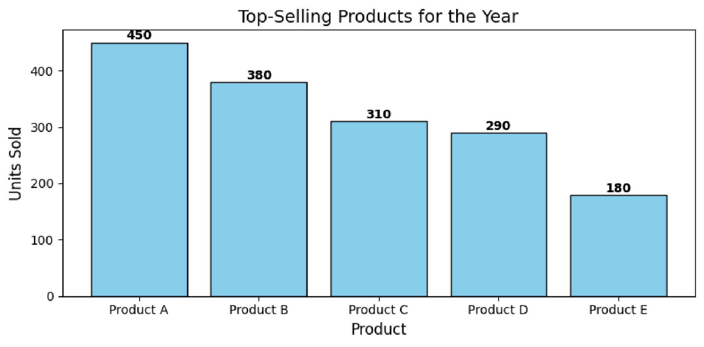
OUTPUT :

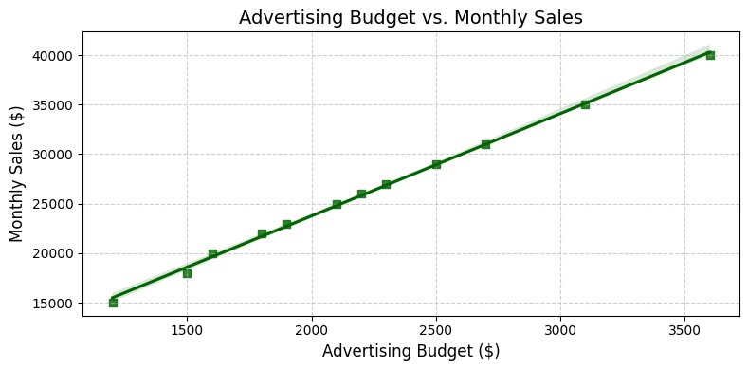
--- Insights from Scatter Plot ---
There is a strong positive linear correlation between advertising budget and monthly sales.
As the advertising expenditure increases, monthly sales steadily rise, suggesting advertising spend directly drives revenue growth.
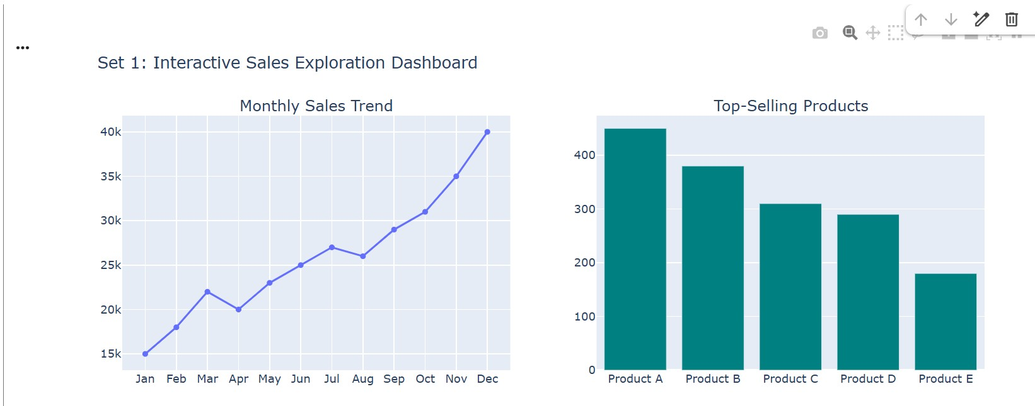

FOR THE VERIFICATION PURPOSE KINDLY FOLLOW THE LINK :
https://colab.research.google.com/drive/1eGUdKVPJJ9KfDh0U4OUeL76Vg10SwLbF#scrol lTo=mxZOC6D0nKjD&fullscreenOutput=true

